McNair Scholars
Seniors and Juniors of Siena Heights University and Adrian College
Seniors:

Jason Baird
Mentor: Dr. Jeffrey Lindstrom
Siena Heights University
“Meditation and the Psychological Benefits to Full-Time College Students”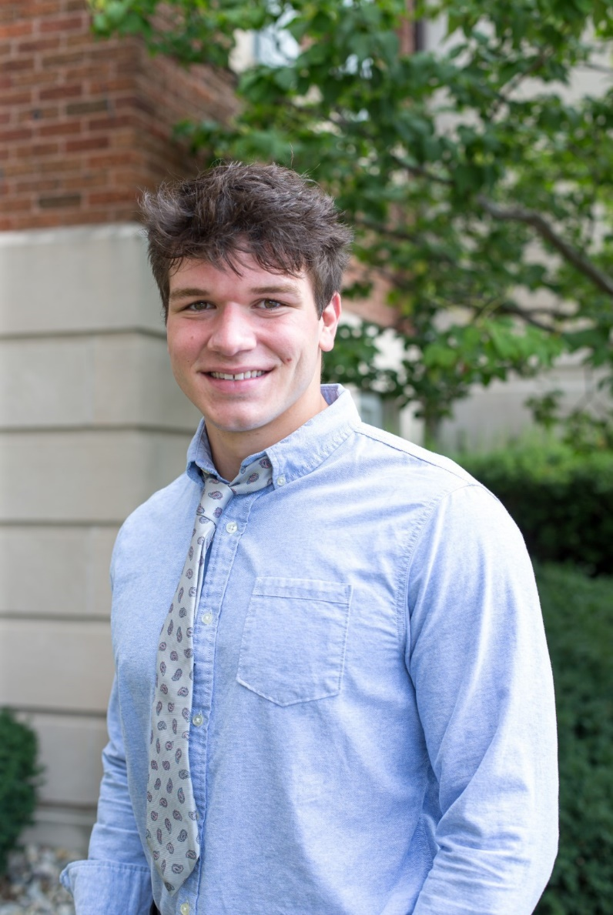
Alexia Ferguson
Mentor: Dr. Julieanna Frost
Siena Heights University
“The Black Lives Matter Movement and Human Rights Efforts”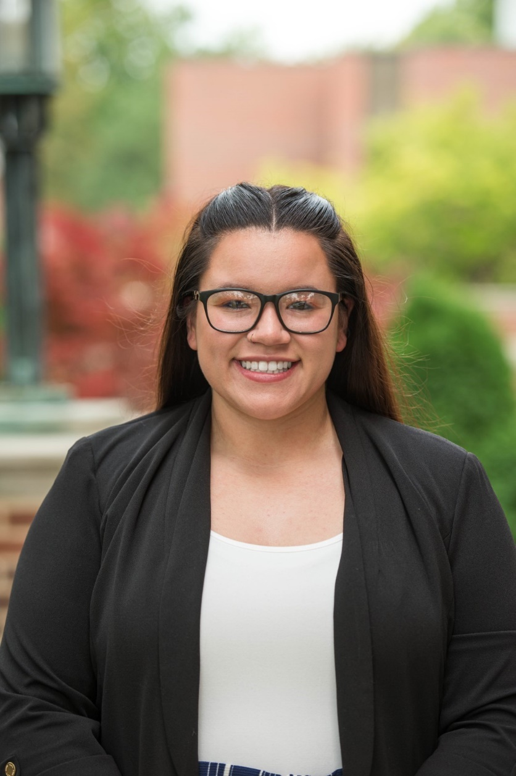
Alyssa Lopez
Mentor: Dr. Patricia Rousselo
Siena Heights University
“The Psychological Effects of Art in College Students”
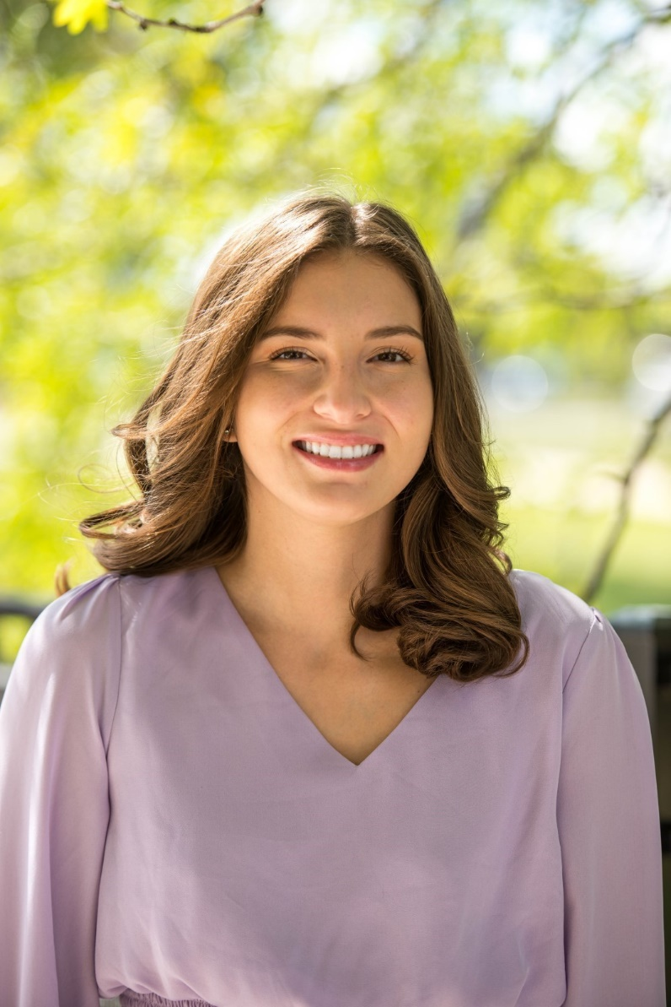
Maddison Vansaw
Mentor: Professor Jonathan Kleinow
Siena Heights University
“Athlete's Versus Non-Athlete's Perceptions of Sexual Violence on College Campus”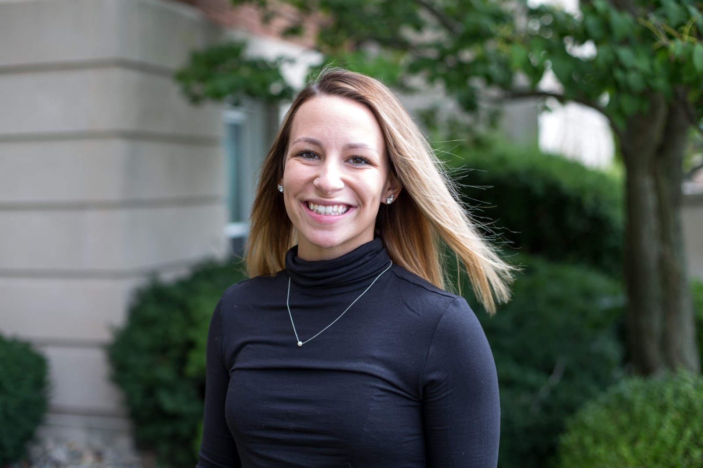
Sara Wallace
Mentor: Dr. Jeffrey Lake
Adrian College
“Temperature Anomalies and Violent Crime in the United States”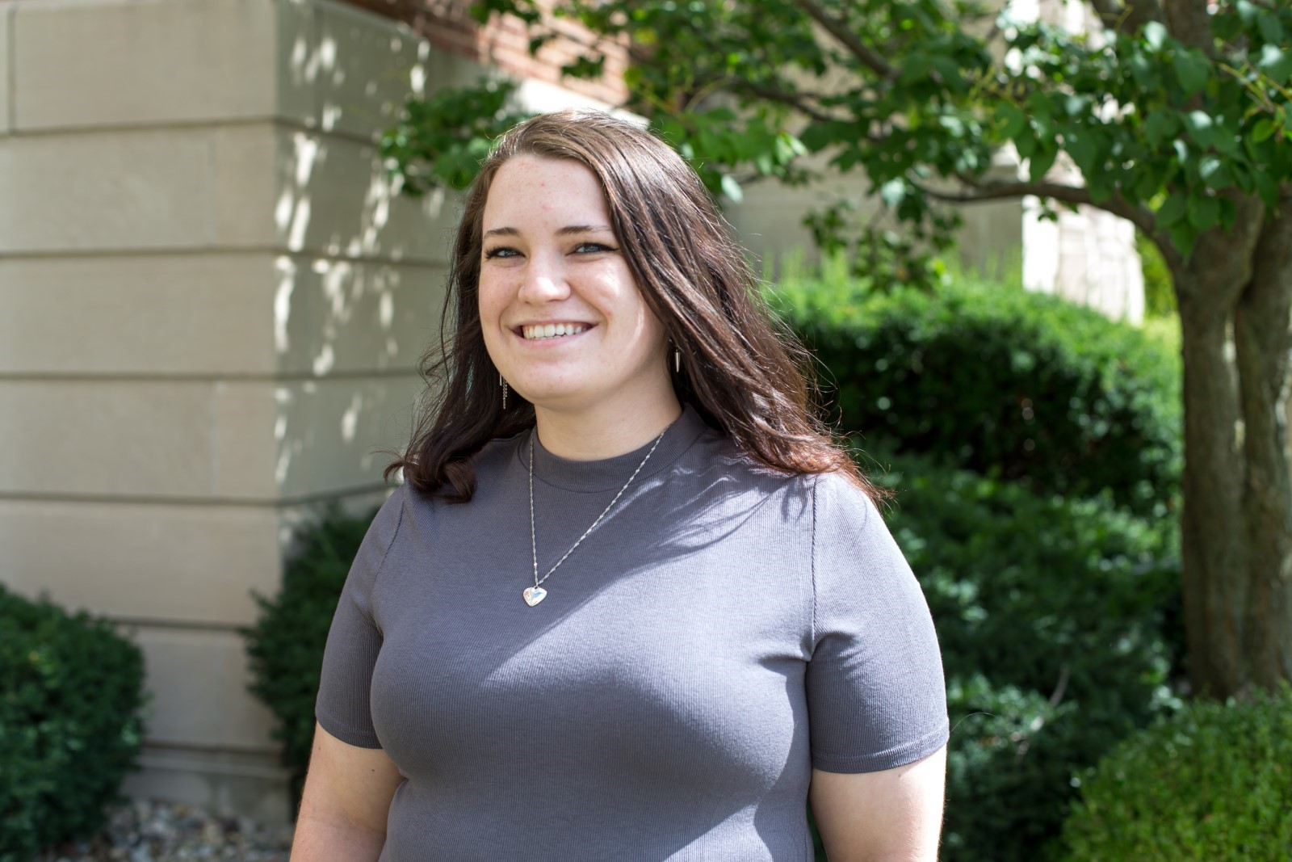
Rayvin Webber
Mentor: Dr. Jeffrey Lake
Adrian College
“A Comparative Analysis of Organic and Inorganic Fertilizers on Plant Growth And Nitrogen Uptake”
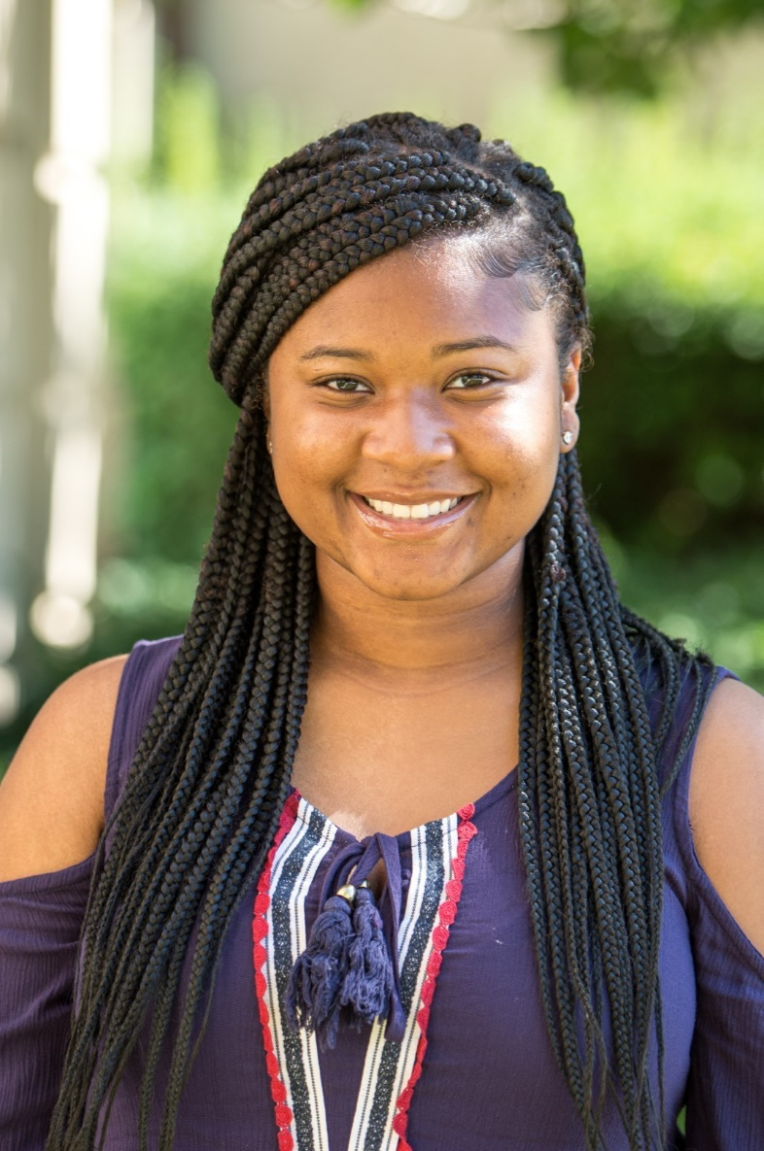

Juniors:

Alexis Cordle
Mentor: Dr. Carl Kaster
Siena Heights University
“Species of Mosquitoes and West Nile Virus in East Lucas County”
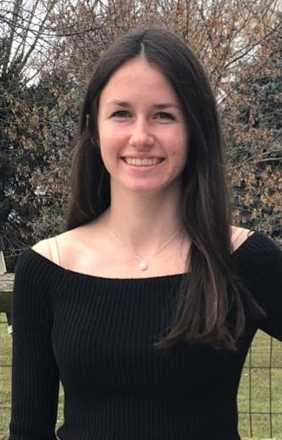
Shanterra Holmes
Mentor: Dr. Julieanna Frost
Siena Heights University
“The Experiences of Women in Healthcare”
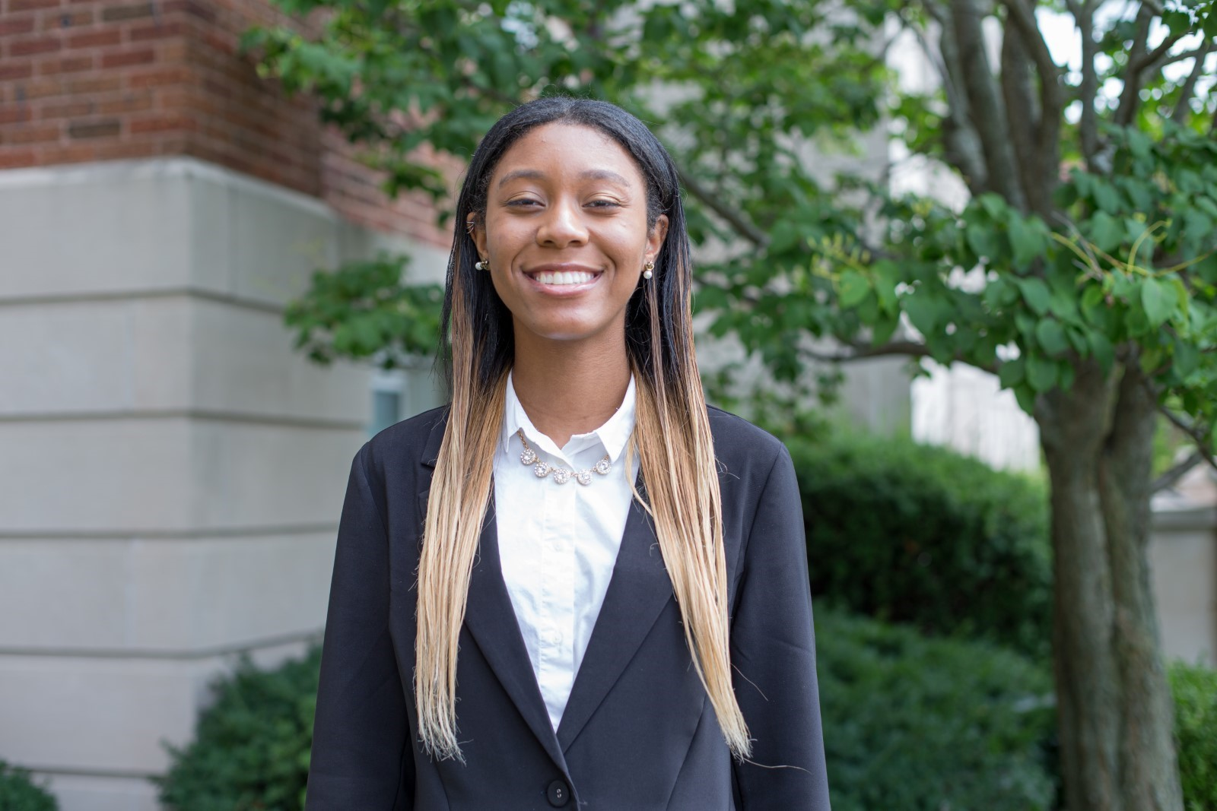
Na’I’Cesses McKether
Mentor: Dr. David Goldberg
Adrian College
“Legal Accountability in the Flint Water Crisis”

Samantha Scott
Mentor: Dr. Carl Kaster
Siena Heights University
“How Phase Feeding and Start-Finish Diets Affect the Weight Gain of Broilers”
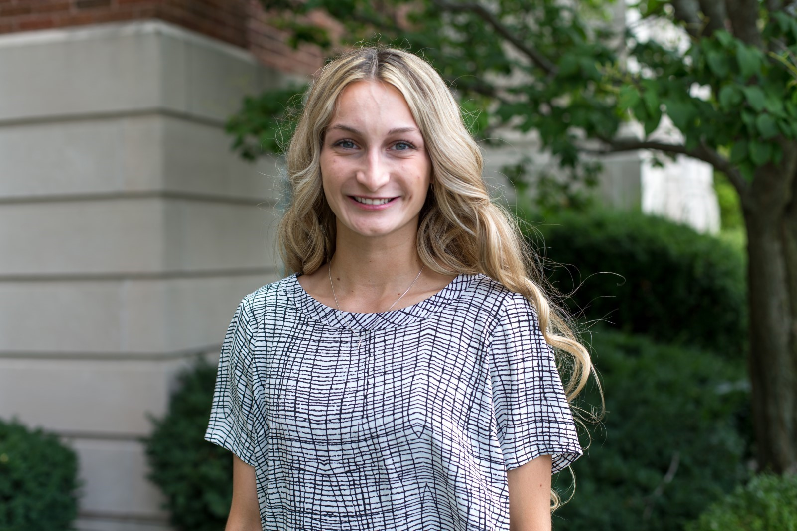
Walter Turner Jr.
Mentor: Dr. Jeffrey Lindstrom
Siena Heights University
“Comparing Stress Between College Athletes & Non-Athletes"
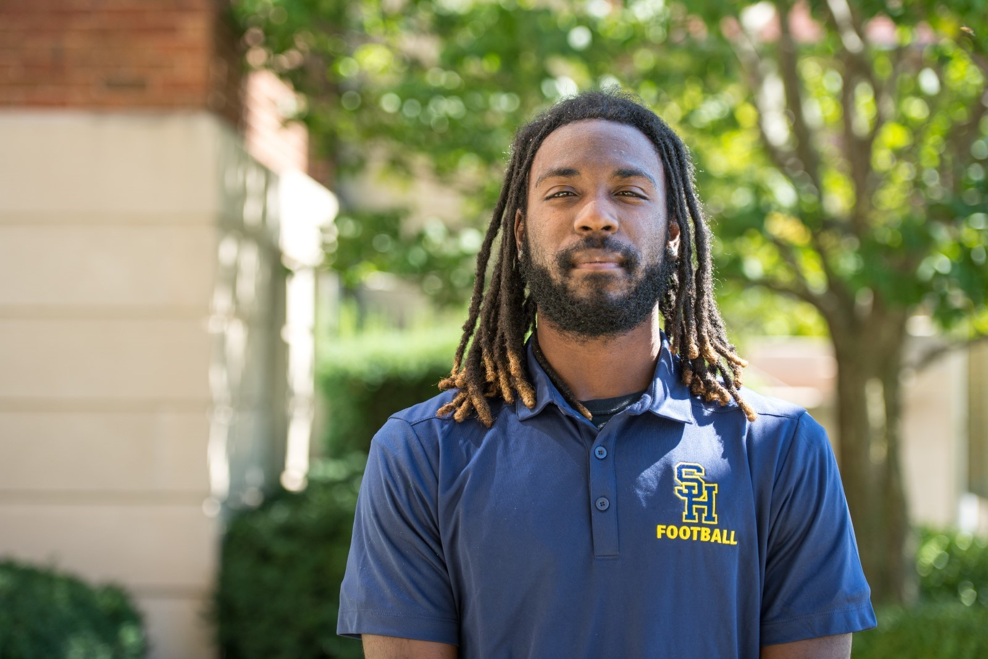
Lillian Walker
Mentor: Dr. Nicholas Mortensen
Siena Heights University
“The Female Athlete Triad: A Survey of Menstrual Function in Collegiate Female Athletes”
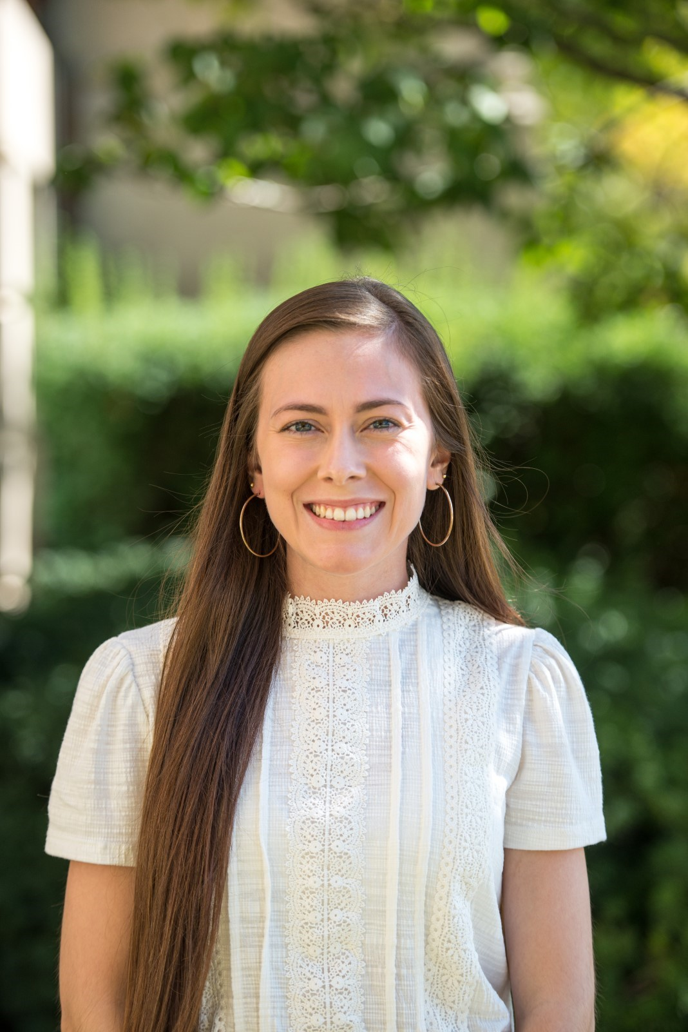
Jalen Williams
Mentor: Dr. Jeffrey Lake
Siena Heights University
“Stereotypes & Perceptions Of African American Male Student-Athletes at Predominately White Institutions”
